Plan Review Application

Mobile
Mobile Facility Layout & Equipment Specifications

Developed by the Food Safety Program at New Philadelphia City Health Department

4/29/2022

Greetings!

We want you to have a successful business! The goal of this publication is to provide you with a clean path to starting your mobile food business in New Philadelphia.

Licensing
All persons in New Philadelphia who intend to prepare, serve, or sell food from a movable vehicle, portable structure, or watercraft that routinely changes location is required by Ohio Law to have a mobile food license issued by the New Philadelphia City Health Department. All new mobile food service operations / retail food establishments and those performing extensive alternations or remodeling must complete the plan review process.

Where do I begin?

Nearly every new or significantly altered facility serving or selling food or beverages in New Philadelphia must submit plans to NCPHD before a license can be issued. A sanitarian in our Food Safety Program will review the plans in order to ensure that the equipment, facilities, and design will be adequate for the food items served or sold at the facility.

This guide will help you determine when you need to submit plans, who you need to get in contact with, and what to expect as far as process and timeline.

What is required in my facility?

Every business is unique. What will be required will be based on your menu. So, you must make sure that you have the space and equipment needed to store, prepare, and serve those foods safety.

Who to Contact?

Office | Service | Contact
New Philadelphia City Health Department | Plan Review and Inspections | (330)-364-4491  Ext: 1208
East Central Ohio Building Authority (ECOBA) | Plumbing Inspections | (330)-364-3164
New Philadelphia Service Director | Building/Zoning, Signage, Water & Sewer Permits | (330)-364-4491  Ext:1275
The City of New Philadelphia Mayor’s Office | Soft Drink License & Coin Operated Machine License | (330)-364-4491  Ext: 1242
The City of New Philadelphia Income Tax Department | Business Tax Information | (330)-364-4491  Ext: 1230
Ohio Department of Commerce/Division of Liquor Control | Liquor License | (614)-664-2360
Ohio Department of Taxation | Vendor’s License-Apply online TAXID#(EIN) | http://business.ohio.gov
Ohio Department of Agriculture | State Agency for Retail Food Establishments | (614)-728-6250
Ohio Department of Health | State Agency for Food Service Operations | (614)-466-1390
Ohio EPA Division of Drinking and Ground Water | Private Water Systems | (614)-644-2752
We want you to have a successful business!

What is a Mobile?
A mobile food service operation is an operation that is operated from a movable vehicle, portable structure, or watercraft; routinely changes location; and does not remain at any one location for more than forty consecutive days.
This definition was developed to address food service operations that are truly of a mobile nature who “routinely” or “regularly” change locations. Moving a mobile unit a few feet or pulling an operation around the block and returning it to the same location does not comply with the intent of the law.

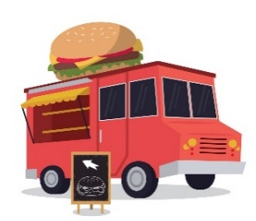
Types of Mobiles
Concession Trailers/Trucks:
Concessions Trailers and Trucks are fully self-contained unit with mechanical refrigeration, a complete plumbing system including hot water tank, and plenty of storage space for multiple day events. These are considered restaurants on wheels.
ALL FOOD SERVED AT THE CONCESSION MUST BE MADE AT THE CONCESSION OR IN A LICENSED FODO FACILITY

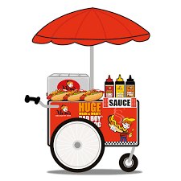
Pushcarts:
Moveable structure facility with approved equipment. This type of facility requires assembly prior to start of each operating event. Must be designed with proper overhead covering and proper floor materials.

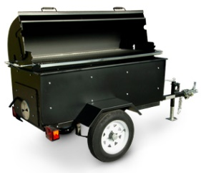
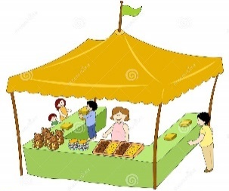
Mobile Cookers / BBQ Pits:
A Mobile Cooker / BBQ pit is an oven on wheels. The cooking unit is mounted to the frame of the trailer unit. The mobile cooker concession must have all the infratusture of a concession tralier. Most mobile cooker trailers utilize an auxillary unit either consisting of another trailer or knockdown conccession.

Knockdown Concessions:
Moveable structure facility with approved equipment. This type of facility requires assembly prior to start of each operating event. Must be designed with proper overhead covering and proper floor materials.

Catering Type Delivery Truck:
Catering type trucks carry prepackaged and non-prepackaged hot and cold type foods. These trucks must ensure that foods can be mainatinaed at the proper holding temperatures at all times. Because these types of trucks only carry prepacked hot or cold foods, they are not required to have a handwashing or three compartment sink. Packaged food on these trucks must come from a wholesale type facility that is inspected and licensed by the Ohio Department of Argiculture. Catering trucks that have any type of commerical food preparation grill or soup warmer must meet the same requirements as a concession trailer.
Frozen Food Trucks/Carts:
A frozen fod trucks or cart is a mobile mortorized or non-motorized concession on wheels that normally contains a commercial freezer and only prepaced frozen products. The frozen food must be received in its frozen state, prepacked, and from a licensed distributor. This is the only licensed unit in which mo plumning system, handwash sink , or three compartment sink is required since no open food or preparation is taking place.

Basic Requirements
There may be local regulations that limit where and when some or all of these types of mobile units operate. An example of this may be a sidewalk vendor or Peddler’s Permit issued by a city. Always contact local permit or zoning departments for additional information and requirements.
All types of mobile units are required to follow all regulations as outlined by the Ohio Uniform Food Safety Code.
The health district must post on the back of each license the layout of the operation including the location and type of major equipment, the menu, the license plate number or unit number, any restrictions or exemptions regarding the unit, commissary location (if applicable), and sanitarian information.
One complete standard inspection must be completed by the licensing health department at least once during the licensing year (conducted prior to obtaining the license). In addition, inspections may be conducted as necessary by the health department as well as other health departments in Ohio in which the licensee is set up and selling their product. When an inspection is conducted by a health department other than the licensing department, a copy of the inspection report may be sent to the health department issuing the license.
All mobile units must have identification on the body of the unit at least 3” tall and 1” wide which contain the following information:
- Mobile unit name
- City, State, and Zip code
- Area code and phone number
Processing License Requirements: All units requiring storage and/or processing of foods outside of unit(s) shall be required to register with the Ohio Department of Agriculture (ODA).
Note: Foods obtained from this storage or processing site without registration from ODA will be considered an unapproved source. Foods prepared from home kitchens are also considered an unapproved source. These foods will not be permitted to be sold, and are subject to embargo or destruction on site.

The original license must be at the unit at all times during operation. Copies of the license are never accepted as substitutes.

Planning

The unique needs of your business will be based on your food selections. Ensure you have the space and equipment needed to safely store, prepare, and serve your food items.

Equipment: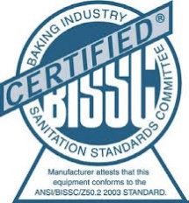
- Commercial-Grade Equipment:
All equipment used must be listed as commercial and must be certified by a recognized testing agency (e.g., NSF, ETL, UL Sanitation).
According to 3717-1-04.1(KK) of The Ohio Uniform Food Safety Code:
“(1) Except as provided in paragraph (KK)(2) of this rule, food equipment that is acceptable for use in a food service operation or retail food establishment shall be approved by a recognized food equipment testing agency.”
No household equipment is permitted.
Suggestion: Place casters on large equipment not already on legs or permanently fixed (caulked) to the floor, to open space for necessary cleaning.

Plumbing Fixtures
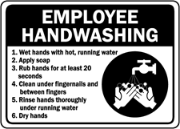
Hand Washing Sinks:
Adequate and conveniently located employee handwashing sinks are a must. Convenient location means that the sink is accessible and visible from any food area. Sinks shall be equipped with soap, disposable towels or hand dryers, and trash cans. Hand washing sinks are required to have signs reminding employees to wash hands and water that reaches at least 100°F.
Note: Each hand sink described in this section can only be used for its designated purpose (e.g., Hand washing, dishwashing, food prep, service sink).

Dishwashing (Warewashing) Sinks:
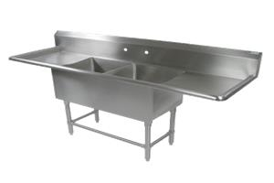
A 3-compartment sink designated for manual dishwashing is required. The sink should have at least three (3) compartments for washing, rinsing, and sanitizing. The sink may also have two (2) drain boards, one for the collection of dirty dishes and the other for air drying.

Food Preparation Sink:
A food preparation sink is required for all food washing, rinsing, soaking, thawing, and cooling. Food Preparation sinks must have indirectly connected drains.
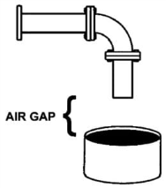
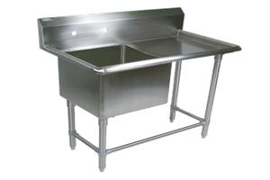
This means installation of an air gap between the discharge pope and the flood level rim; equal to no less than 1 inch or 2 times the diameter of the discharge pipe.

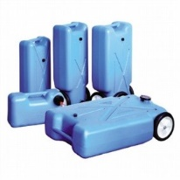
Sewage Holding Tank:
Also called a “blue boy,” this is a required item for all sewage produced if the mobile food service unit is not directly connected to sanitary waste disposal while in operation. The tank must be sized to hold fifteen percent (15%) greater fluid capacity than the water supply tank. It must also be sloped to a drain that is one inch (1”) or twenty-five millimeters (25mm) in diameter or greater, and be equipped with a shut-off valve. NOTE: Sewage must be disposed of properly. Holding tanks shall not create a public health risk by conveying sewage.

Food Grade Hose:
Direct water connections require food grade hoses. NOTE: green garden hoses are not permitted for water inlet lines to mobile units. Food grade hoses come in many colors, all of which are acceptable when properly marked as such by manufacturer. Ensure hoses are clearly identified as “food grade”, NSF or FDA certified by the manufacturer.
ASSE 1012
ASSE 1024
Backflow Prevention Device:
All directly connected water lines shall have a proper backflow prevention device. Mobile food service units may use an ASSE 1012 or ASSE 1024 dual check backflow prevention device. NOTE: All built-in backflow prevention devices shall be made visible for inspection and/or be clearly documented on mobile unit equipment specification sheets.
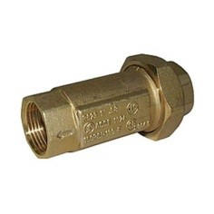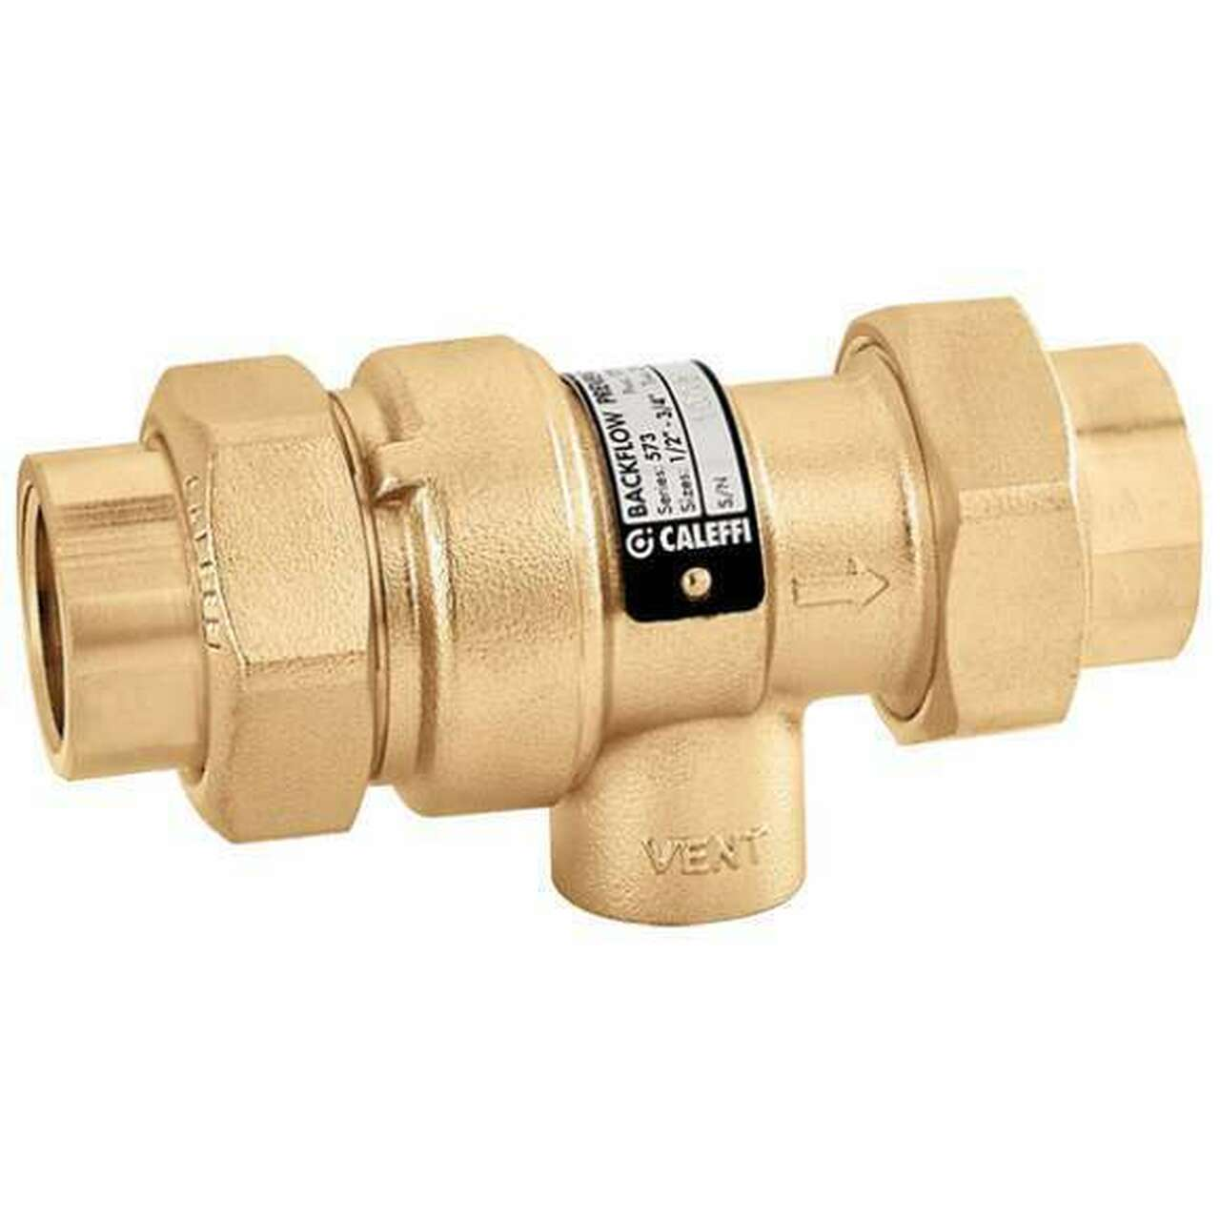

Additional Equipment Considerations. . .

Adequate Lighting:
Lighting must be bright enough for safe working conditions and cleaning. General lighting intensity requirements are:
- 50 foot candles--cooking area, food prep areas, food service areas
- 20 foot candles-- customer self-service, inside equipment (e.g. reach in cooler), handwashing, dishwashing, utensil storage, restrooms
- 10 foot candles--walk-in coolers and freezers, dry storage, and other areas
Note: When submitting lighting plans to ACHD for plan review ensure indication of :
- The type and location of lighting fixtures
- Description of plastic covers, shatterproof bulb or shields to protect food and equipment

Smooth and Cleanable Surfaces:
All floors, walls, and ceilings in the facility must be smooth and easily cleanable. Approved surfaces which are frequently used:
- Floors: sealed concrete, poured epoxy, various types of tile
- Walls: glossy painted drywall, painted concrete block, stainless steel, FRP
- Ceilings: glossy painted drywall (no acoustic tile), vinyl coated drop ceiling
- Base covering: rubber, tile
Note: Make sure plans include the type of floor and wall coverings chosen.

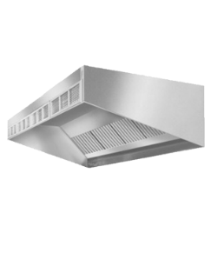
Ventilation Hoods:
A ventilation hood is required for a grill line, or where any other cooking equipment or a high temperature dish machine is located. Installation of a ventilation hood requires:
- A permit
- inspections

Fire Suppression System:
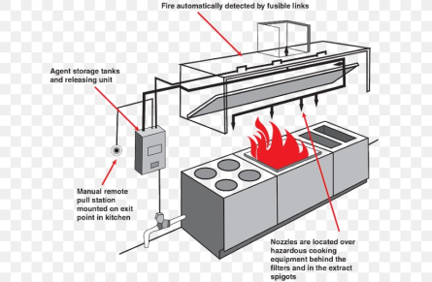
If a ventilation hood is required for grease production (due to fryers, a grill, etc.) a Type I Hood with fire suppression is required. If a hood is required for heat consideration or gas only, a Type II Hood may be allowed.

Storage

Dry Storage:
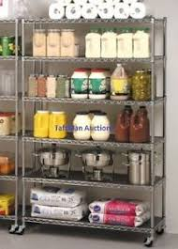
Ensure adequate space for storage of dishes, food, and equipment. Designated locations should be laid out for all types of items. All food and single service items must be stored at least 6” off the floor on storage shelving (including in walk-in coolers and freezers). Look for food grade shelving; unsealed wooden shelves are not allowed.
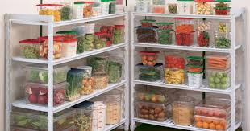
Note: trash cans and other such non-food grade containers cannot be used for food storage. Large bins of bulk items (e.g., rice, flour, sugar, etc.) must be made of food grade material and labeled with the name of the food inside.

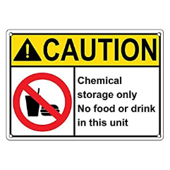
Chemical Storage:
In order to prevent contamination, chemicals must always be stored below and/or away from food, equipment, and utensils (including dishwashing sinks). Chemical bottles must also be labeled.

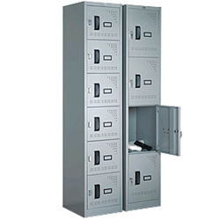
Employee Personal Storage:
Lockers, shelves, or another designated area shall be provided for employee belongings. Items such as coats, backpacks/purses, phones, open drinks, cigarettes/vaporizers cannot be located in food prep areas.

Note: please ensure all beverages include both a lid and a straw if used in food prep areas.

Facility Self Checklist

Here are some important elements that you should start to think about. During future inspections, similar questions may be asked.

Facilities

- Do you have enough hot water capacity for peak times of business?
- Do you have enough storage space needed for all purposes?
- If you plan to expand the operation, will you have available space?
- Are floors, walls, and ceilings constructed of smooth and easily cleanable material?

Equipment

- Do you have enough space in your commercial coolers and freezers?
- Can you prevent overstocking and allow for required air circulation?
- How will you keep hot foods hot?
- How will you keep cold foods cold?
- Do you have thermometers for all coolers and hot holding equipment?
- Do you have proper thermometers for taking food temperatures?

Services

- Who will provide foods, and are they all from approved sources?
- Who will provide your waste pickup?
- Who will provide grease waste pickup and grease interceptor cleaning services?
- Who will provide certified pest control?
- Who will maintain your hood system and/or fire suppression system?
- Who will provide maintenance for your dishwasher, if one is used?

Employee Training

- When and how will you train your staff about food safety?
- Is food safety training required based on the risk level of the facility?
- Will one person from the facility acquire food protection manager (level II) certification?
- Will one person from the facility become food handler (level I) certified?
- What food safety practices will be covered during staff orientation?
- What is your employee health policy and how is it documented?
- Do you have a written policy and necessary equipment to handle a bodily fluid spill?

Processes

- What will be your process for date marking ready-to-eat foods?
- What will you use to avoid bare hand contact with ready-to-eat foods?
- How will you ensure that a ‘first-in, first-out’ system is used for foods?
- Do you have enough commercial cooler space for overnight thawing?
- Do you have enough commercial cooler/freezer space to allow for proper cooling?
- Will you keep cooling temperatures logs? Who will be responsible?

Requirements

- One (1) complete set of site and floor plans (as detailed below):
Note: Additional sets of plans may be required for plumbing review.
  - Site plan including location of building, alleys, streets, and outdoor equipment (dumpsters, wells, grease traps, sewage systems, etc.)
  - Floor plan showing areas used for the business, entrances/exits, walls, plumbing, electrical services, mechanical ventilation and location of all equipment required.
Note: Zoning approval may be required
- Type of mobile food operation
- Retail Food Establishment (RFE) -or- Food Service Operation (FSO)
- Proposed menu
- Food processes
- Total square footage of the operation
- Location, number and types of plumbing fixtures, including all water supply connection
- Lighting plan
- Building materials and surface finishes used
- Equipment list including all manufacturers and model numbers
- Food protection training certificate
- Submission of the above along with appropriate plan review fee
- Certificate of Occupancy
- Water Supply: Public or Private-may need approval from Ohio EPA, Division of Drinking and Ground Water
- License Application with original signature and date of the applicant after plans have been submitted, approved and a pre-licensing inspection conducted
- Payment of appropriate food license fee.

**You must have your plans approved based on a pre-licensing inspection which will occur prior to issuance of your FSO or RFE License**

Getting Started

Step 1: Submittal of Plans (Application should be at least 30 days prior to construction)
- Complete the attached Plan Review Application
- Submit one (1) complete set of drawings and other applicable information for the facility
- Submit menu or complete list of food and beverage items to be sold.
- Submit the list of equipment including manufacturer and model numbers
- Submit food protection certifications
- Submit the plan review fee(s)

Step 2: Plan Review process
- NPCHD will review plans within 30 calendar days of submission and payment. If additional information or changes are required, you will likely be contacted. Changes require a new plan review application submission. Re-submission of plan review will begin a new 30-day process timeframe.

Step 3: Approval
- Information with plan approval will be sent via letter. Plan approvals expire 1 calendar year from approval date. Submit application after plan approval.

Step 4: Construction
- Ensure that all contractors and subcontractors are properly licensed.
- Ensure that your contractors obtain all necessary permits through the:
  - Building, Zoning, or Plumbing Department
  - Fire Department
  - EPA approval for water

**Your license will not be issued without approval from the departments listed above**

Step 5: Inspection
- Prior to opening your establishment, you must have a pre-licensing inspection by NCPHD.
- The license will not be issued until the facility meets all of the applicable code requirements at the time of the pre-licensing inspection.
- You must submit written documentation that all of the building and/or fire inspections have been completed and passed before a license will be issued.
- Once your plans are finally approved, application and payment is made and the pre-licensing inspection is completed by NCPHD, you will be able to open for business.
Note: NCPHD personnel will make all attempts to accommodate your timeline for the pre-licensing inspection. Please contact us at least 10 business days in advance of your target opening date to schedule this inspection. Planning ahead helps avoid scheduling conflicts and allows time for re-inspections, if necessary.

Type of Food Establishment:

- Food Service Operation (FSO)- Primary business is on-site preparation and/or consumption of ready-to-eat foods in individual portions (e.g. concession trailers/trucks, pushcarts, knockdown concession, etc.)

- Retail Food Establishment (RFE)-primary business is the sale of food in bulk portions for off premise consumption and/or preparation (e.g. frozen food trucks, etc.)

Primary business is defined through sales volume. If your facility operates as both a food service operation (FSO) and a retail food establishment (RFE), whichever potion of your business has the greater sales volume (51% or more) determines your designation (either FSO or RFE).

What is My Plan Review Fee?

Please contact New Philadelphia City Health Department at (330)-364-4491 ext: 1208 to determine your Plan Review fees.

Education Requirements:

As of March 1, 2010, the Ohio Revised Code requires that all food service operations and retail food establishments opened after this date have at least one person-in-charge per shift that has a minimum of level one certification in food protection or an equivalent approved training within 90 days of being licensed.

As of March 1, 2017, each risk level 3 and risk level 4 food service operations and retail food establishment must have at least one management or supervisory employee with a level two certification in food protection. This certification is obtained through the Ohio Department of Health after completing an approved course (15 hours of instruction and passing a comprehensive exam). A ServSafe certificate itself and the level one certificate does not comply with this rule.
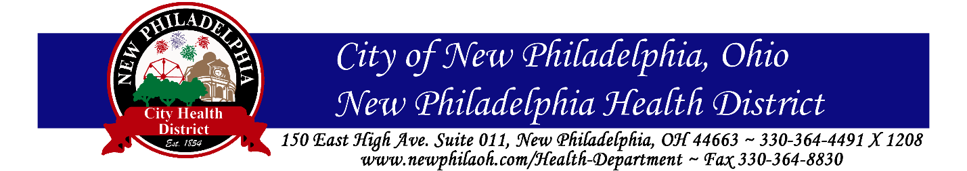

New Philadelphia City Health Department
Food Safety Program Plan Review Application

Facility Information:

Name of Facility: _______________________________________________________________________

Address of Facility:______________________________________________________________________

City: ______________________ State: _____________________ Zip Code: ______________________

Applicant / Operator Information

Name of Owner: _________________________________ Phone #: _____________________________

Mailing Address for License Renewal: ______________________________________________________

City: ______________________ State: _____________________ Zip Code: ______________________

Contact Person (For Plan Review Response):

Name: ____________________________________ Title (Owner, Architect):_______________________

Phone #: __________________________ Address: ___________________________________________

City: _____________________ State: ____________________ Zip Code: ________________________

Plan Review Type: (Check what applies)

𝥀New construction or facility has never operated as a food facility

𝥀Remodel or extensive alteration of an existing licensed food facility

𝥀 Change in ownership

Type of Establishment:

𝥀Food Service Operation (FSO) 𝥀 Retail Food Establishment (RFE)

General Information:

What are the hours of operation? ______________________ Seating Capacity? ___________________

Total square footage? ______________________ Will part of the operation be outdoors? 𝥀Yes 𝥀No
- If yes, what is the total outside square footage? _________________

Will there be at least one person-in-charge per shift with a minimum of Level One Certification in Food Protection? 𝥀 Yes 𝥀No

Will there be at least one PIC that has management or supervisory responsibilities with a Level Two Certification in Food Protection? 𝥀 Yes 𝥀 No

Are copies of the employee Level One and Level Two (if applicable) certificates enclosed? 𝥀Yes 𝥀No

Do you have a written sick policy that ensures your food employees are informed (in a verifiable manner) of their responsibilities to report to the PIC information about their health as it relates to diseases that are transmissible through food? 𝥀 Yes 𝥀No

Do you have a written procedure for employees to follow when responding to vomiting or diarrheal events that address how to minimize the spread of contamination and the exposure to employees, consumers, and surfaces? 𝥀 Yes 𝥀 No

The following information must be included as part of your plan review.

Please indicate the following components are included (✔) or not applicable (N/A)

Components | (✔) or (N/A) | Official Use Only
Plan Review Fee made payable to New Philadelphia City Health Department
Type of facility proposed (FSO, RFE)
Proposed Menu (Complete list of food items to be prepared, served, sold)
Facility floor plan or layout, drawn reasonably to scale (to include):
- Total square footage to be used ____________
- Location of dry goods and chemical storage
- Location of personal belongings storage
- Location of designated hand sinks
- Location of the three compartment sink
- Location of food preparation sink (must have indirect waste line)
- Location of all equipment
- Potable water souce
Lighting Plan
Interior finishes (materials for floors, walls, ceilings, and coverings)
Equipment list, include make and model numbers (commercial equipment only NSF, or equivalent)
Plumbing Plan (location, type, and number of all plumbing fixtures)

**Failure to provide all information may result in a delay or disapproval of your submittal**
Food Prep and Storage:

Is the required menu or list of food items to be prepared, served, or sold enclosed? 𝥀 Yes 𝥀No

Provide a list of your food suppliers and the delivery frequency:

____________________________________________________________________________________________________________________________________________________________________________________________________________________________________________________________________________________________________________________________________________________

Will your menu have a consumer advisory per OAC 3717-1-3.5? 𝤿 Yes 𝥀 No

Does your facility cater as defined in ORC 3717.01(G): 𝥀 Yes 𝥀 No
- If yes, this section is intended for food that will be served by establishment employees off-site from the planned establishment. This section does not pertain to the delivery of pre-ordered food to a customer (e.g. delivery of pizza).

List of menu items:
____________________________________________________________________________________________________________________________________________________________________________________________________________________________________________________________________________________________________________________________________________________

Maximum number of meals per day taken to or prepared at off-site location: ______________________

How will hot food be held at the proper temperature during transportation and at the off-site location?

____________________________________________________________________________________________________________________________________________________________________________________________________________________________________________________________________________________________________________________________________________________

How will cold food be held at the proper temperature during transportation and at the off-site location?

____________________________________________________________________________________________________________________________________________________________________________________________________________________________________________________________________________________________________________________________________________________

What types of vehicle(s) will be used to transport the food? ____________________________________

If this operation performs a food handling process that is not addressed, deviates, or otherwise requires a variance (such as reduced oxygen packaging, smoking for preservation, bottling or canning) is the required written HACCP plan enclosed along with ODH or ODA approval for this process?
𝥀 Yes 𝥀 No 𝥀 N/A
Will food be stored at least 6 inches above the floor? 𝥀 Yes 𝥀 No

Will food shields be used to protect foods on display? 𝥀 Yes 𝥀 No

How will employees avoid bare hand contact with ready-to-eat foods?

____________________________________________________________________________________________________________________________________________________________________________________________________________________________________________________________________________________________________________________________________________________

Will you be cooling food? 𝥀 Yes 𝥀 No
- If yes, list all of the food you are cooling:
____________________________________________________________________________________________________________________________________________________________________________________________________________________________________________________________________________________________________________________________________________________

- Also include your methods of cooling from 135°F-70°F within 2 hours and from 70°F-41°F within 4 hours:
____________________________________________________________________________________________________________________________________________________________________________________________________________________________________________________________________________________________________________________________________________________

Will you be reheating food in bulk (more than one serving) to 165°F or higher? 𝥀 Yes 𝥀 No
- If yes, list all of the food you are reheating:

____________________________________________________________________________________________________________________________________________________________________________________________________________________________________________________________________________________________________________________________________________________

- Also include your method of reheating:

____________________________________________________________________________________________________________________________________________________________________________________________________________________________________________________________________________________________________________________________________________________

Equipment and Utensils:

Will all equipment and utensils be commercially certified with NSF or equivalent? 𝥀 Yes 𝥀 No

Will each refrigerator, freezer, or warmer have a temperature measuring device? 𝥀 Yes 𝥀 No

Will temperature measuring devices be provided, readily accessible, and properly calibrated to ensure that the temperature of the food product is being accurately measured? 𝥀 Yes 𝥀 No 𝥀 N/A

Is the required equipment list with make and model numbers enclosed? 𝥀 Yes 𝥀 No

If utensils used with moist foods such as ice cream, or mashed potatoes are not stored in the product, will the required dipper well be provided? 𝥀 Yes 𝥀 No

Are all containers used to store bulk food products constructed of safe materials designed to be in direct contact with food? 𝥀 Yes 𝥀 No

To provide for easy cleaning will equipment be installed with: 𝥀 Casters 𝥀 Gas Disconnects 𝥀 A seal at the wall and floor 𝥀Sufficient open space

Manual Warewashing:
Will the dimensions of the three-compartment sink be large enough to accommodate the largest food contact surface completely submerged (including large pots & pans)? 𝥀 Yes 𝥀 No

Dimensions of each compartment of the three-compartment sink are _____ inches long _____ inches wide _____ inches deep.

Will the required drain-boards be provided on both ends of the three-compartment sink? 𝥀 Yes 𝥀 No

Will the hot water temperature delivered to the sink be 120°F-140°F? 𝥀 Yes 𝥀 No

What type of sanitizer will be used? 𝥀 Chlorine 𝥀 Quaternary Ammonia 𝥀 Other_______________

Will test papers be available to verify the concentration of sanitizer being used? 𝥀 Yes 𝥀 No

Plumbing and Fixtures:

Will all plumbing work be completed under permit from the plumbing authority? 𝥀 Yes 𝥀 No 𝥀N/A

Will the location and size of the grease interceptor be compliant with state plumbing codes as well as local ordinances (if applicable)? 𝥀 Yes 𝥀 No 𝥀 N/A

Will all equipment drain lines, exposed utility service lines, and soda/beer lines be installed so as to not interfere with floor cleaning? 𝥀 Yes 𝥀 No

If the menu or layout dictates, are these dedicated dump sinks available? 𝥀 Yes No 𝥀 N/A
If produce is washed or frozen foods are thawed in a sink will the required dedicated food prep sink with an indirect (air gapped) drain be provided? 𝥀 Yes 𝥀 No 𝥀 N/A
Will the drains of the following equipment be provided with at least a two-inch air gap? | Yes | No | N/A
Ice Machine
Ice Storage Bins
Food Processing Sinks
Steam Tables
Dipper Wells
Steam Kettles and Ovens
Three-Compartment Sink
Other: _________________________________________

Water Supply:

Are you on city water? 𝥀 Yes- city:___________________ 𝥀 No- water system:__________________

Handwashing:

Will there be a dedicated hand sink available within 20 feet of any food handling or ware washing area without going around a corner or through a doorway? 𝥀 Yes 𝥀 No

Will all hand sinks be installed in a manner that prevents splash contamination to food and food contact surfaces? 𝥀 Yes 𝥀 No

Is hot and cold running water under pressure available at all hand sinks? (Note: hot water shall be a minimum temperature of 100 °F)? 𝥀 Yes 𝥀 No

Handwashing instructional signs are required at each hand washing sink. Will signs or posters be provided at each hand sink? 𝥀 Yes 𝥀 No

Soap and paper towel dispensers are required to be installed at all handwashing sinks. Have soap and paper towels been provided? 𝥀 Yes 𝥀 No

Garbage Storage and Disposal:

What type of receptacle storage will be used? 𝥀 Compactor 𝥀 Dumpster 𝥀 Cans

What is the anticipated minimum pickup frequency? __________________________________________
Will all outdoor refuse receptacles. . .?

- Be placed on a paved surface? 𝥀 Yes 𝥀 No
- Be rodent proof and leak proof? 𝥀 Yes 𝥀 No
- Curbed and sloped to drain? 𝥀 Yes 𝥀 No
- Have tight fitting lids/covers? 𝥀 Yes 𝥀 No
- Be shown on the enclosed site plan? 𝥀 Yes 𝥀 No

Describe how and where waste grease from equipment (e.g. fryers) will be handled, stored, and disposed of: __________________________________________________________________________________________________________________________________________________________________________

Is there an outdoor grease storage receptacle? 𝥀 Yes 𝥀 No

Is there an area designated for garbage can or floor mat cleaning? 𝥀 Yes 𝥀 No

Describe any inside solid waste storage or solid waste container cleaning area:
__________________________________________________________________________________________________________________________________________________________________________

Where will damaged merchandise or unacceptable products to be returned will be stored?
__________________________________________________________________________________________________________________________________________________________________________

Describe how and where redeemables, returnables, and recyclables will be stored:
__________________________________________________________________________________________________________________________________________________________________________

Mark the types of materials that will be recycled: 𝥀 Glass 𝥀 Metal 𝥀 Paper 𝥀 Cardboard
𝥀 Plastic 𝥀 None

What is the anticipated minimum recycling pickup frequency? __________________________________

Insect and Rodent Control:

Will outside doors be self-closing? 𝥀 Yes 𝥀 No

Will openings around pipes, electrical conduits, and other wall perforations be sealed? 𝥀 Yes 𝥀 No

Will all openings to the exterior (doors, windows, ventilation discharges, etc.) be designed to keep out rodents and insects? 𝥀 Yes 𝥀 No

If you want to leave an exterior door open, it must be supplied with a tight-fitting screen that meets both building and fire codes. Is your facility compliant? 𝥀 Yes 𝥀 No 𝥀 N/A
Lighting:

Will at least 50 foot-candles of light be provided at:
- Food preparation areas? 𝥀 Yes 𝥀 No 𝥀 N/A
- Areas employees work with utensils or equipment? 𝥀 Yes 𝥀 No 𝥀 N/A

Will at least 20 foot-candles of light be provided at:
- Inside equipment? 𝥀 Yes 𝥀 No 𝥀 N/A
- Areas used for handwashing? 𝥀 Yes 𝥀 No 𝥀 N/A
- Areas used for warewashing? 𝥀 Yes 𝥀 No 𝥀 N/A
- Areas used for equipment storage? 𝥀 Yes 𝥀 No 𝥀 N/A

Will at least 10 foot-candles of light be provided at:
- Walk-in coolers and freezers? 𝥀 Yes 𝥀 No 𝥀 N/A
- Dry storage areas? 𝥀 Yes 𝥀 No 𝥀 N/A

Will the required shielding or shatter-resistant lamps be provided for light fixtures in food storage preparation, display, or service areas? 𝥀 Yes 𝥀 No 𝥀 N/A

Ventilation:

Will a commercial exhaust hood with an approved fire suppression system be provided to service cooking equipment producing grease-laden vapors? 𝥀 Yes 𝥀 No 𝥀 N/A

Will the canopy hoods completely cover the cooking equipment (extending a minimum horizontal distance of 6 inches beyond the edge of the cooking surface on all open sides)? 𝥀 Yes 𝥀 No 𝥀 N/A

Will a commercial exhaust hood be provided to service a hot temperature dish machine? 𝥀 Yes 𝥀 No

Interior Finishes:

All room finished on floors, walls, and ceilings in areas where sinks, urinals, toilets, dish machines, areas subject to food splash/vapors, food/wet bars, buffet lines, drink dispensing areas, mop sinks/service sinks, steam tables and areas where food preparation equipment is located are required to be durable, smooth, easily cleanable, and impermeable to moisture. Fiberglass Reinforced Plastic (FRP), tile, stainless steel, or other approved materials such as painted drywall or sealed block are required.

Is your facility compliant with this rule? 𝥀 Yes 𝥀 No

Complete the following chart to indicate all interior finishes:

Area | Floor | Walls | Coved Base | Ceiling
Example | Quarry Tile | FRP | Rubber Base Molding | Vinyl Acoustical Tile
Food Preparation
Cooking
Warewashing
Food Storage
Other
Other

General Facility Considerations:

Will a separate storage area be provided for employees personal belongings? 𝥀 Yes 𝥀 No

Will all toxic chemicals be stored away from food preparation and storage areas? 𝥀 Yes 𝥀 No

Where will cleaning supplies and chemicals be stored? ________________________________________

Will laundry facilities be located on premise? 𝥀 Yes 𝥀 No

Where will clean linens be stored? ________________________________________________________

Where will soiled linens be stored? ________________________________________________________

Is the completed NPCHD Plan Review Checklist enclosed with the material submitted? 𝥀 Yes No

Plan Review Submission

This application is complete and accurate to the best of my knowledge. I understand that an incomplete submittal may delay the plan review process. I understand that any deviation from the initial submittal without prior approval from NPCHD may nullify final approval.

I have enclosed a completed NPCHD Plan Review Checklist.

I have enclosed the plan review fee.
Signature of applicant: _____________________________________________ Date: _______________

