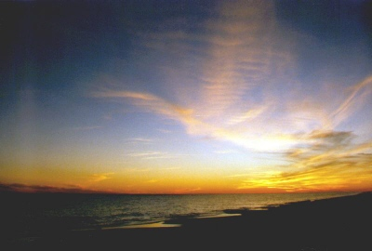

CEMETERY BOARD

MEETING MINUTES

MARCH 12, 2020
8:00 AM

The meeting was called to order by Mayor Joel B. Day. Present were members Mark Wideman, Service Director Ron McAbier, Dave Frantz, Jim Exley, Aimee May and Superintendent Kelly Herron. Excused was Rich Geib and Tim Halter.

Minutes from the January, 2020 meeting were approved on a motion by Ron McAbier and seconded by Dave Frantz. Motion passed unanimously.

SUPERINTENDENT’S REPORT:
Mr. Herron reported during the last windstorm, a tree fell on part of a fence in Section F in Evergreen. He stated that the Fair Avenue cemetery building is being vandalized. A door and windows have been damaged. Dave Frantz asked what the decision had been when the idea of razing this building was brought up before. Superintendent reported that it was estimated at $15,000 to raze it. Mr. McAbier said at this point it would be best to secure it and not raze it.

Mr. Herron told members that Chris Borne, longtime maintenance worker at NP City Schools, has offered to provide labor and materials to erect concrete/brick pillars for the entryway to the new cemetery, similar to the look at Evergreen, as was provided by his family members in the past.

Superintendent Herron announced his retirement effective May 29, 2020. Here’s wishing Mr. Herron many years of happiness long into the future!!

OLD BUSINESS:
Service Director McAbier reported on the January bid openings for the construction of the new cemetery garage. The three bids came in at $94,000; $96,000 and $124,000, way over estimate. Changes were made, mostly with the labor cost of the foundation. It was re-bid and the lowest bid came in at $76,400 ($71/sq ft). Considering $31,000 is the approximate amount for materials and $6,600 allowed for HVAC, Mr. McAbier still feels this bid is about $15,000 over estimate. Discussion was then had on the idea of being our own general contractor and if that would be financially beneficial. Board Member, Dave Frantz suggested another idea to combine the bid to include the office building as well. The office building estimate is $135,000. Mr. McAbier and Superintendent Herron will have endowment figures available as well as more information to present to the board before or at the next regularly scheduled Cemetery Board meeting.

NEW BUSINESS:
Mayor Day reported that Tom Adamich emailed him regarding the Donahey family grave sites. Mr. Adamich thought it would be fitting to erect a historic marker on Tuscora Park property facing the Steve Stokey house on North Broadway, the former Donahey residence as well as a marker at the cemetery. He will contact KSU Tuscarawas and Dee Grossman, Director of the Visitors and Convention Bureau for sponsorship.

Meeting adjourned at 8:33 a.m. on a motion from Ron McAbier, seconded by Jim Exley.

Mary Ann Otte
Administrative Assistant

